Assignment 1: Task 1
Project Plan/ Proposal
SmartPantry- Smart Food Waste Reduction App

Team members: Sujina Tuladhar (E2300582)
Pasang Lama (E2400050)
Manav Rawal( E2300560)
Table of Contents
1.0 Overview 1
2.0 Project Aims 2
3.0 Project Objectives 3
4.0 Project Scope 4
4.1 In Scope 4
4.2 Out of Scope 4
5.0 Project Schedule 5
5.1 Work Breakdown Structure (WBS) 5
5.2 Milestone / Deliverable 7
5.3 Gantt Chart 8
6.0 Technical Description 9
6.1 Development Platform 9
6.2 Demonstration Platform 10
7.0 Risk Management Plan 11
8.0 GitHub Link 12
9.0 References 12

1.0 Overview
Malaysia is one of the highest per capita food waste producers in Southeast Asia, with waste production of about 16,688 tons per day (Solid waste and Public Cleansing Management Corporation [SWCorp] 2023). Poor food inventory management, lack of expiry date, awareness and no platform for food sharing are the main reasons for the majority of waste coming from household waste in the country. According to Yeong (2024), Malaysians waste food worth billions of ringgit annually, despite many households facing rising food costs. SmartPantry is proposed to be a direct solution to this critical environmental and social problem, not only to support the United Nations Sustainable Development Goal 12 (Responsible Consumption and Production), but also aligned with the National Food Security Policy of Malaysia.
The primary customers and users of SmartPantry are individuals and families of Malaysian household, who buy, store and cook food at home. Secondary users are community members who would like to give away extra food or receive food from neighbors in their neighborhood.
SmartPantry is a new product as there is no existing system being extended. It will be designed from scratch to be a fully functional web based application with six major use cases which will include User registration and Privacy Settings, Manage food inventory, Browse food items and donations, food analytics, View notifications and Plan weekly meals.
The financial cost to the client is none since it is an academic project that is produced as part of the BIT216 Software Engineering principles course at HELP University. All development will be completed by us three team members as per question. Throughout the project, we will be using some free and open source tools like Ganttproject for scheduling, GitHub for version control, Figma(free) for wire framing and development framework: React.js/Node.js will be used.
The project will be done in 14 weeks starting from 18/05/2026 to 21/08/2026 based on Iterative and incremental with 2 iterations. Usecases 1 through 3 will be finishedd by July 14, 2026, in Iteration 1, and Usecases 4 through 6 will be finished by August 21, 2026, in Iteration 2.

2.0 Project Aims
The aims of the SmartPantry project are:
- To develop a functional and user-friendly web-based application that helps Malaysian households manage their food inventory and reduce food waste.
- To provide a community-driven food donation platform that enables users to share surplus food with others.
- To promote responsible meal planning by enabling users to plan weekly meals based on their available food inventory.
- To raise awareness of individual food waste impact through visual analytics and progress tracking.
- To ensure user data privacy and account security through authentication mechanisms including two-factor authentication (2FA).

3.0 Project Objectives
By the end of the project our team will have:
- A functional web application, all 6 use cases are fully implemented and have passed user acceptance testing.
- Developed a food inventory module which can be used to add food items, edit, delete, and categorize them with expiry dates, and generates alerts automatically when food items are coming up to their expiry date.
- Built a food donation browsing and claiming module which allows users to post, browse and claim food donations with pickup information.
- Implemented a food analytics dashboard that displays visual charts and progress indicators for food saved and donated over time.
- Developed a notification system to provide reminders and timely notifications for expiry dates, donations status, and meal planning.
- Created a weekly meal plan that correlates inventory items with meal time and recommends recipes from ingredients.
- Built out all modules with working prototypes with test cases and GitHub Collaboration evidence for Iteration 1 and Iteration 2.

4.0 Project Scope

4.1 In Scope
The following features are within the scope of this project:
- Registered and authentication user login/logout/management, including optional 2FA.
- Food inventory management: add, edit and delete food items along with name, quantity, expiry date, category and storage place.
- Donation module: inventory item to donation listing, donation browse, items with pick up confirmation.
- Food analytics - visual reports of food saved from waste and food donated, filtered by date range and category.
- Automated alerts for items that are close to their expiration dates, updates on donation opportunities and meal plan reminders.
- Weekly meal planner: Plan meals by day, view possible meals from what's available.

4.2 Out of Scope
The following are not included in this project:
- Payment or e-commerce functionality.
- Mobile native application (iOS/Android) as platform is web-based only.
- Integration with external food database or 3rd party recipe API - recipe suggestions will be based on what food items are available.
- Admin panel or moderation features, for managing users throughout the platform.
- Immediate chat or messaging between donors and recipients.
- Multi language (English only in first release).

5.0 Project Schedule

5.1 Work Breakdown Structure (WBS)
No. | Activity/Task |  | Milestone/ Deliverable | Duration  (hrs) | Duration  (days) | Precedence | Sujina | Pasang | Manav
1 Planning
1.1 | Determine Project Title |  |  | 0.5 | 1 | NIL | 100 | 100 | 100
1.2 | Write the Overview |  |  | 1 | 1 | 1.1 | 100 | 0 | .
1.3 | Write the Aims & Objectives |  |  | 2 | 1 | 1.1 | 0 | 100 | 0
1.4 | Write the Scope |  |  | 2 | 1 | 1.1 | 0 | 0 | 100
1.5 | Derive WBS |  |  | 8 | 1 | 1.4 | 100 | 100 | 100
1.6 | Determine  Milestones |  |  | 2 | 1 | 1.5 | 100 | 100 | 100
1.7 | Derive Gantt  Chart |  |  | 8 | 1 | 1.7 | 100 | 100 | 100
1.8 | Derive Technical  Platform |  |  | 3 | 1 | 1.7 | 100 | 0 | 0
1.9 | Derive Risk  Management Plan |  |  | 3 | 1 | 1.7 | 0 | 100 | 100
1.10 | Project Plan/Proposal |  | Milestone/Deliverable |  |  | 1.9 | 100 | 100 | 100
2 Requirements
2.1 | Determine Functional & Non-Functional Requirements |  |  | 8 | 2 | 1.9 | 100 | 100 | 100
2.2 | Modeling Requirements (User Stories, AC, Tasks) |  |  |  |  | 2.1
2.2.1 | UC1-User Registration & Privacy Settings |  |  | 8 | 2 | 2.1 | 100 | 0 | 0
2.2.2 | UC2-Manage Food Inventory |  |  | 8 | 2 | 2.1 | 0 | 100 | 0
2.2.3 | UC3 - Browse Food Items & Donations |  |  | 8 | 2 | 2.1 | 0 | 0 | 100
2.2.4 | UC4 - Food Analytics |  |  | 8 | 2 | 2.1 | 100 | 0 | 0
2.2.5 | UC5 – View Notifications |  |  | 8 | 2 | 2.1 | 0 | 100 | 0
2.2.6 | UC6 – Plan Weekly Meals |  |  | 8 | 2 | 2.1 | 0 | 0 | 100
 | Requirements Specifications Document (docx) |  | Milestone/Deliverable |  |  | 2.2.6 | 100 | 100 | 100
3 Design
3.1 |  | Design UX / Wireframes |  |  |  | 2.3
3.1.1 |  | Wireframes UC1 – User Registration |  | 4 | 1 | 2.3 | 50 | 0 | 0
3.1.2 |  | Wireframe UC2 – Food Inventory |  | 4 | 1 | 2.3 | 0 | 50 | 0
3.1.3 |  | Wireframe UC3 – Browse Donations |  | 4 | 1 | 2.3 | 0 | 0 | 50
3.1.4 |  | Wireframe UC4 – Analytics Dashboard |  | 4 | 1 | 2.3 | 50 | 0 | 0
3.1.5 |  | Wireframe UC5 – Notifications |  | 4 | 1 | 2.3 | 0 | 50 | 0
3.1.6 |  | Wireframe UC6 – Meal Planner |  | 4 | 1 | 2.3 | 0 | 0 | 50
3.2 |  | Design Site Map (Hierarchy Diagram) |  | 4 | 1 | 3.3.1, 3.3.2, 3.3.3, 3.3.4, 3.3.5, 3.3.6 | 100 | 100 | 100
3.3.1 |  | Design ERD |  | 4 | 1 | 2.3 | 100 | 0 | 0
3.3.2 |  | Design Data Dictionary |  | 4 | 1 | 3.3.1 | 0 | 100 | 100
3.4 |  | Architectural/Deployment Diagram |  | 4 | 1 | 3.3.2 | 100 | 100 | 100
3.5 |  | Design Specification Document | Milestone/Deliverable |  |  | 3.4 | 100 | 100 | 100
4 Iteration 1 – Core Features
4.1 |  | Code & Test UC1: User Registration & Privacy |  | 40 | 5 | NIL | 100 | 0 | 0
4.1.1 |  | Working UC1 Feature | Milestone |  |  | 4.1 | 100 | 0 | 0
4.2 |  | Code & Test UC2: Manage Food Inventory |  | 56 | 7 | 4.1.1 | 0 | 100 | 0
4.2.1 |  | Working UC2 Feature | Milestone |  |  | 4.2 | 0 | 100 | 0
4.3 |  | Code & Test UC3: Browse Food Items & Donations |  | 40 | 5 | 4.2.1 | 0 | 0 | 100
4.3.1 |  | Working UC3 Feature | Milestone |  |  | 4.3 | 0 | 0 | 100
4.4 |  | Integration Testing – Iteration 1 |  | 16 | 2 | 4.3.1 | 100 | 100 | 100
4.5 |  | Iteration 1 Prototype | Milestone/Deliverable |  |  | 4..4 | 100 | 100 | 100
5 Iteration 2 – Advanced Features
5.1 |  | Code & Test UC4: Food Analytics |  | 32 | 4 | 4.5 | 100 | 0 | 0
5.1.1 |  | Working UC4 Feature | Milestone |  |  | 5.1 | 100 | 0 | 0
5.2 |  | Code & Test UC5: View Notifications |  | 32 | 4 | 5.1.1 | 0 | 100 | 0
5.2.1 |  | Working UC5 Feature | Milestone |  |  | 5.2 | 0 | 100 | 0
5.3 |  | Code & Test UC6: Plan Weekly Meals |  | 32 | 4 | 5.2.1 | 0 | 0 | 100
5.3.1 |  | Working UC6 feature | Milestone |  |  | 5.3 | 0 | 0 | 100
5.4 |  | Integration Testing – Iteration 2 |  | 16 | 2 | 5.3.1 | 100 | 100 | 100
5.5 |  | User Acceptance Testing (UAT) |  | 24 | 3 | 5.4 | 100 | 100 | 100
5.6 |  | Bug Fixing & Regression Testing |  | 16 | 2 | 5.5 | 100 | 100 | 100
5.7 |  | Performance & Security |  | 8 | 1 | 5.7 | 100 | 0 | 0
5.8 |  | Final System :Assignment 2 Submission | Milestone/Deliverable |  |  | 5.8 | 100 | 100 | 100

5.2 Milestone / Deliverable
ID | Milestone / Deliverable | Target Date
MI | Project plan Submitted (Assignment1 Task 1) | 12th June 2026
M2 | Requirements Doc Submitted | 18th June 2026
M3 | Design Specification Document | 24th June 2026
M4 | Iteration 1 Complete Prototype | 14th July 2026
M5 | Iteration 2/ Assignment Submitted | 21st August 2026

5.3 Gantt Chart
GanttProject was used to construct the following Gantt chart which displays the baseline project timeline along with task dependencies, resource allocation and milestones
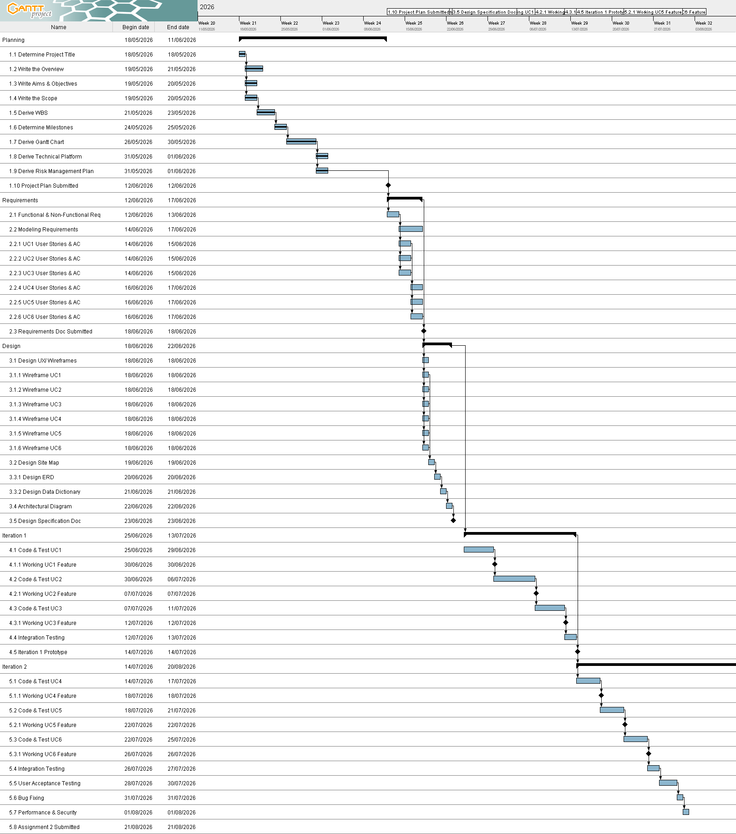
Figure 1 Gantt Chart

6.0 Technical Description
SmartPantry will be built in a web based applicatioon using the React.js and Django. The system is client server based with a RESTful API backend, a PostgreSQL database. The push notifications for expiry alerts and donation updates are managed through Firebase Cloud Messaging and websocket.

6.1 Development Platform
The following tables describe the methods, tools, languages, and environments used for the design, implementation, testing, and documentation of SmartPantry.
Criteria | Tools/ Hardware | Version | Description
Documentation | Microsoft word/ Google Docs | Office 365/ Latest | For project reports and assignment documentation
Documentation | APA 7th Edition | 7th Ed. | Referencing and citation standard
Modelling - Requirement | Draw.io / Lucidchart | Latest | Use case diagrams, activity diagrams
Modelling- Design | Figma | Latest | UI/UX wireframes and prototype design
Project Management | Ganttproject | 3.x | Baseline and tracking Gantt chart creation
Collaboration | GitHub | Latest | Version control and code repository
Collaboration | Microsoft | Latest | Team communication and file sharing
Framework- Frontend | React.js | Latest | Component based web UI development
Framework-Backend | Django(python) | Latest | Python framework for scalable secure API development
Database | PostGreSQL | Latest | Relational database for user and inventory data
Notification Service | Firebase Cloud Messaging (FMC), Web socket | Latest | Push notification delivery service
Testing | pytest | Latest | Unit and integration testing framework
Hardware (Dev) | Dell- Intel core i5/LOQ- Intel Core i7/ Asus Expertbook intel core i5 | -

6.2 Demonstration Platform
Criteria | Tools/ Hardware | Version | Description
Browser | Google chrome | Latest | Primary demonstration browser
OS | Windows 10/11 | Latest | Demo environment operating system
Hardware | Dell- Intel Core i5/ LOQ- Intel Core i7/  Asus- Intel Core i5 | -

7.0 Risk Management Plan
Risk Name | Description | Probability | Mitigation strategy
Scope Creep | A team member continues to add features over what was originally planned, adding to the stress and missing deadlines. | High | Fully defining the scope in the documentation and reviewing it before adding any features and agree on any changes to the scope with all three members.
Low User Adoption | Following its availability, Malaysian families do not download or utilize the app. | Medium | Conducting usability testing with at least 10 users.
Data Privacy Breach | Unauthorized access to user personal data and food inventory information | Low | Using HTTPS encryption by implementing 2FA login
Team Member Unavailability | This is when a member falls behind due to academic workload or personal reasons | Medium | Informing all 3 members on modules, keeping GitHub updated daily so anyone can continue the work
Technology Integration Failure | PostGreSQL or notification service fails during development | Low | Testing all integrations early, using free tier tools with strong community support build fallback options
Miscommunication Among Team | Members of the team generate work that is incompatible or misunderstanding the requirements. | Medium | Conducting weekly team meetings, using GitHub for version control
Technical Knowledge Gap | A team member lacks skills to implement a specific feature causing delays | Medium | Organizing knowledge sharing sessions, distributing duties according to each member's skills, and making hard aspects simpler.

8.0 GitHub Link
https://github.com/sujina8/SmartPantry.git

9.0 References
- Yeong, A. (2024). How Malaysians are battling food waste with surplus food. FairPlanet. https://www.fairplanet.org/editors-pick/how-malaysians-are-battling-food-waste-with-surplus-food/
- United Nations. (2023). Sustainable development goal 12: Responsible consumption and production. United Nations Department of Economic and Social Affairs. https://sdgs.un.org/goals/goal12

